Our team is redesigning the Alta Fiber mobile app.

METHODS:

* Discuss with your group which methods you intend to use for project 3 design research.

The methods our groups intend to use for the project are methods:

* 1. Capture UI/UX metrics, with a focus on self-reported metrics

G) System Usability Scale

H) Survey

We decided on these by voting and then discussing on the, shown below:

* Joe F – I would like to use method A, C, and G for our design research.
* Eli P – I would like to use A, B, and G
* Chimaroke U – I would like to use G and H.
* Create a plan for how you will accomplish these methods.

We can split each method between an individual, so for the methods we decide on, each person will pick one to do. We picked 3 methods and have 4 people, so one person will be left with reviewing and assistance as needed.

-Eli P – Method H - Survey

-Chimaroke U – Method A – Capturing UI/UX metrics

-Joanne O – Method G – SUS, System Usability Scale

-Joe F – Assist as needed

* Draft the materials for these methods.  If you are conducting a survey, write the survey.  If you are doing an interview, what are some of your interview questions.  If observational study with think aloud or time/errors, what tasks will you give you participants.

Eli P - Survey:

1. How often do you use the altafiber app? not often / sometimes / often
2. How frequently do you use the help button? not often / sometimes / often
3. On a scale of 1-5 how would you rate the overall user interface on looks?
4. On a scale of 1-5 how convenient is it to pay your bill?
5. On a scale of 1-5 how easy is it to find the bill summary and information?
6. On a scale of 1-5 how important is simplicity on the app to you?
7. On a scale of 1-5 how transparent is the billing cycle and due dates?

Joanne O – System Usability Scale:

[System Usability Scale: Altafiber Mobile App – Collaboration](https://forms.office.com/Pages/DesignPageV2.aspx?subpage=design&FormId=bC4i9cZf60iPA3PbGCA7Y0roHs_iCJ5BhygUSgIqgaBUMDVIVURTQTFPVTQ3NUJIUk5aRkk4RlFYRS4u&Token=3f294eaf284a416ab25c9f4c27e81eaa) (MS Form)

[System Usability Scale: Altafiber Mobile App – Fill out form](https://forms.office.com/r/dLamNBBHq7)

1. I think that I would like to use the Altafiber mobile app frequently.
2. I found the system unnecessarily complex.
3. I thought the system was easy to use.
4. I think that I would need the support of a technical person to be able to use this system.
5. I found the various functions in this system were well integrated.
6. I thought there was too much inconsistency in this system.
7. I would imagine that most people would learn to use this system very quickly.
8. I found the system very cumbersome to use.
9. I felt very confident using the system.
10. I needed to learn a lot of things before I could get going with this system.

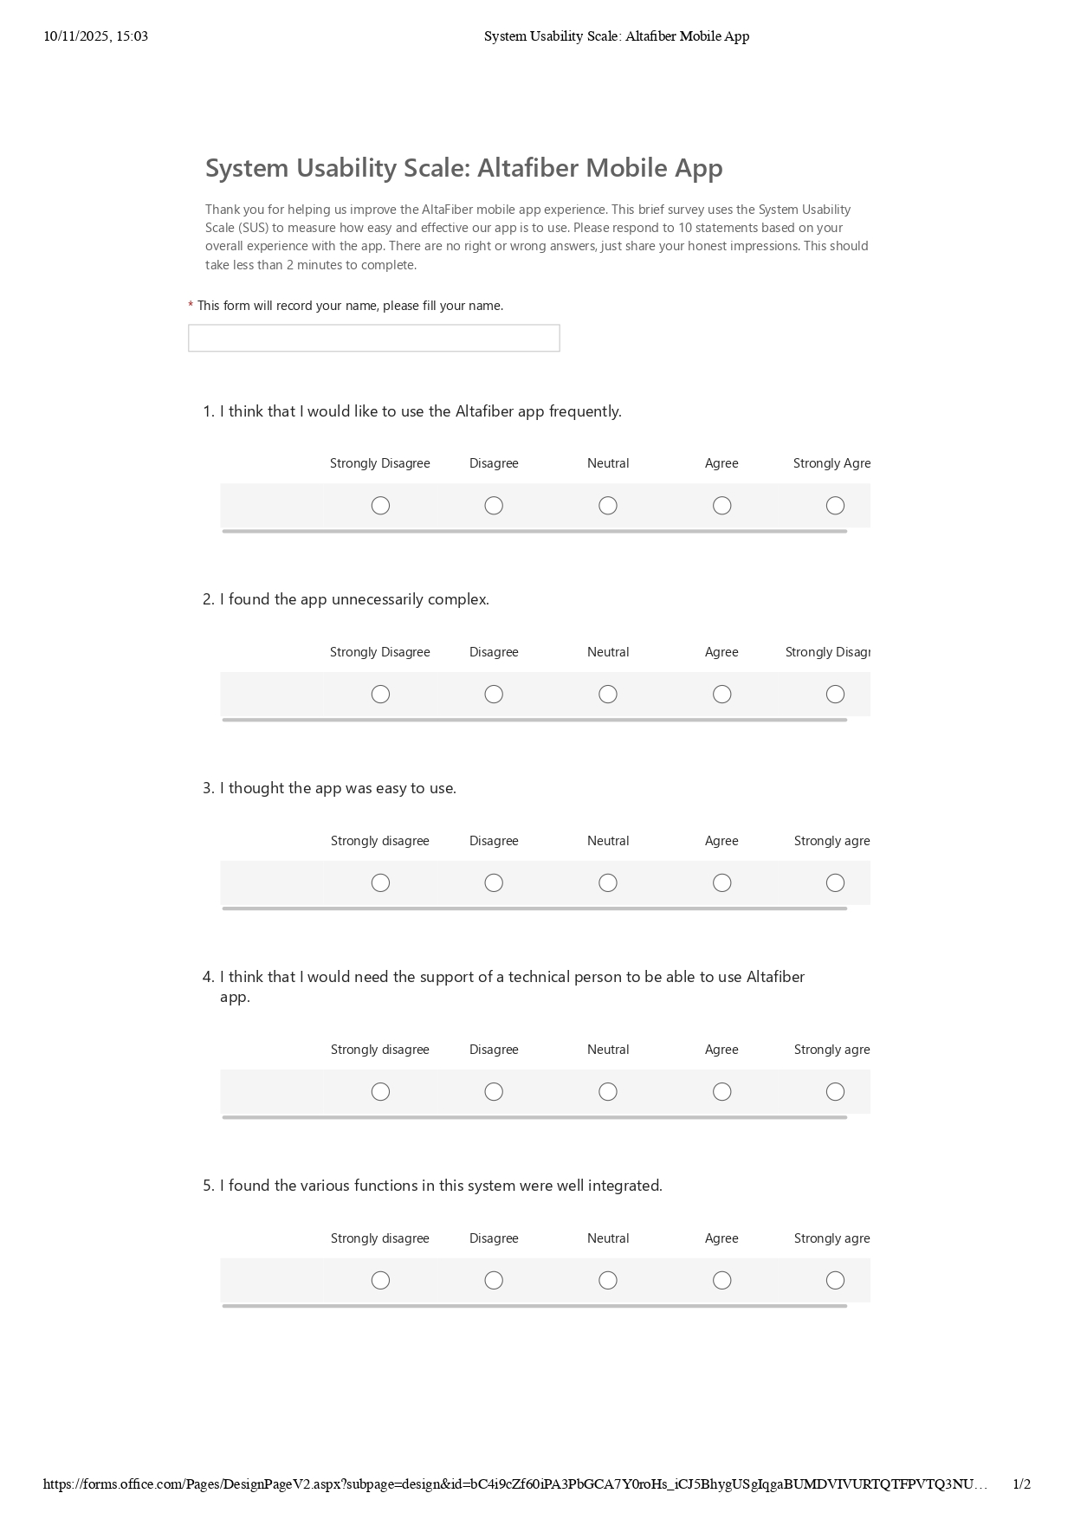

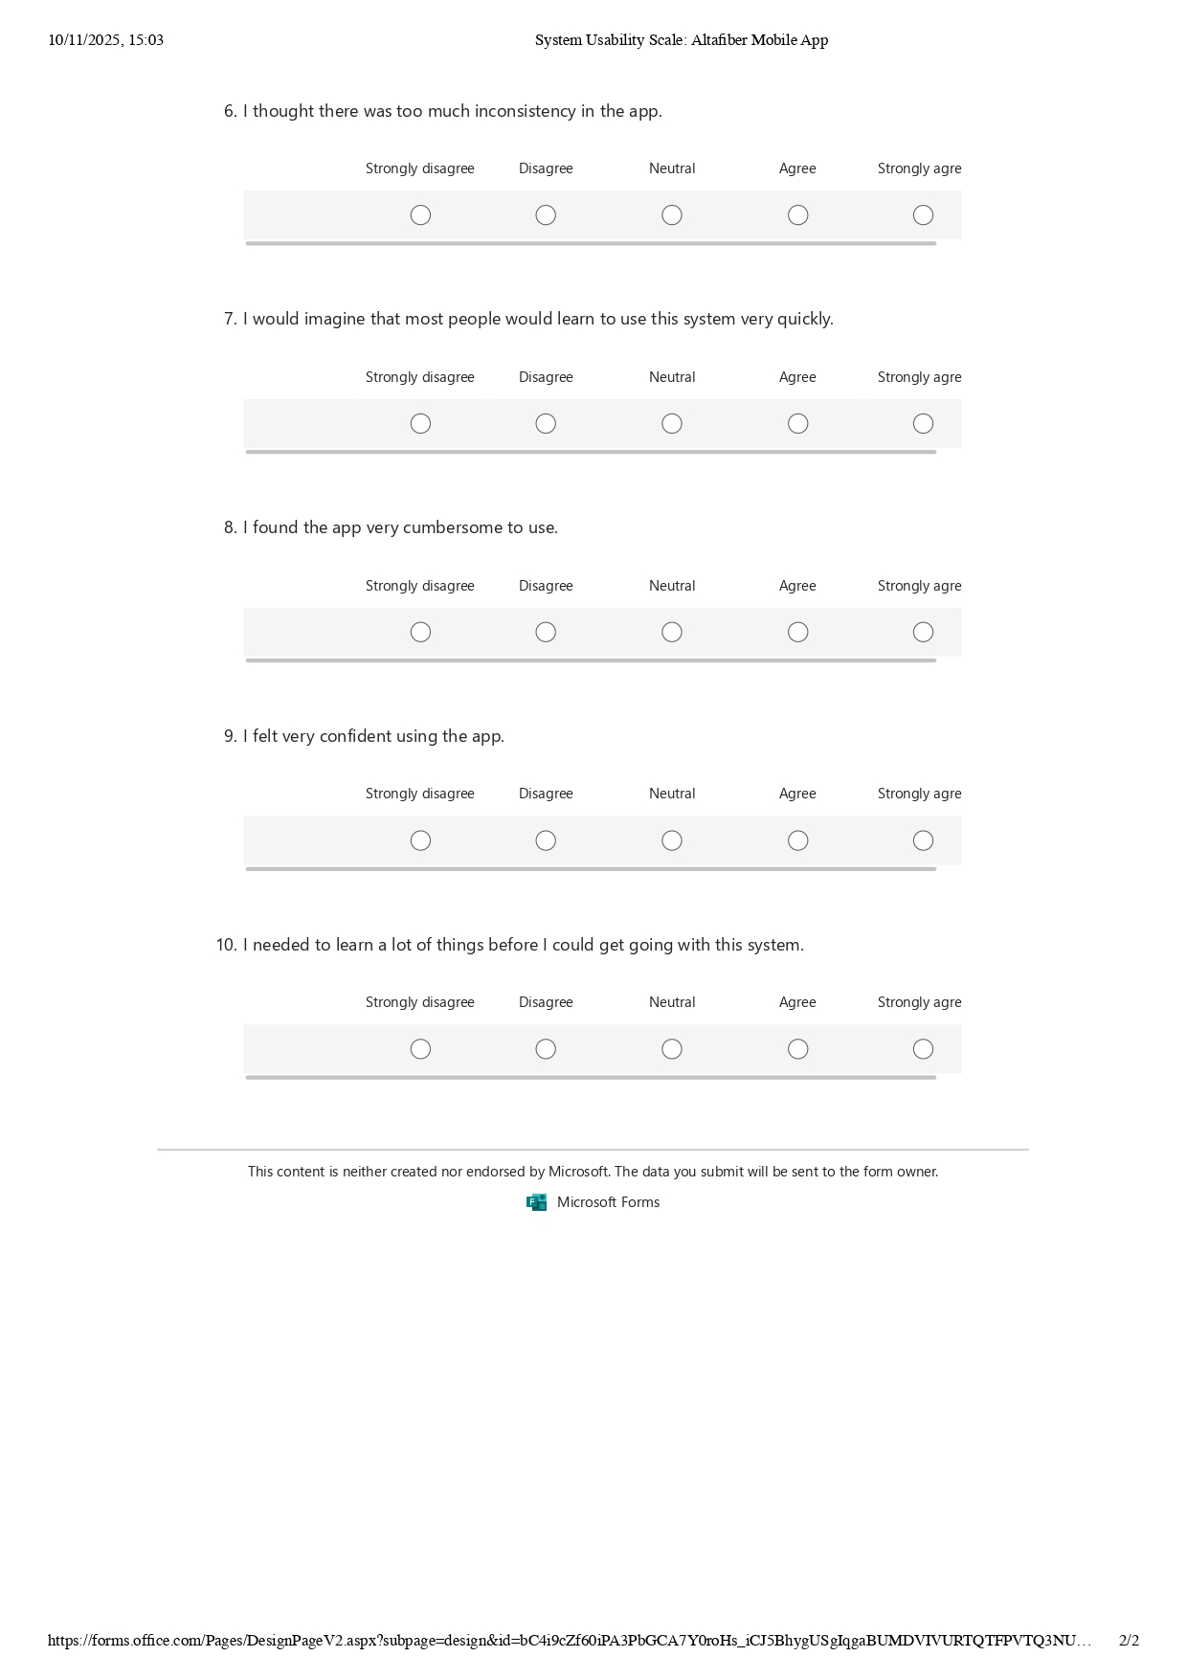

Raw Results: <https://mailuc-my.sharepoint.com/:x:/r/personal/osuchuji_mail_uc_edu/_layouts/15/Doc.aspx?sourcedoc=%7B3FEAAD09-E03D-4B9C-90E6-08C47C4E0D10%7D&file=System%20Usability%20Scale_%20Altafiber%20Mobile%20App.xlsx&action=edit&mobileredirect=true&wdMsFormsCorrelationId=5fbcab44-26eb-40a4-a443-05ed4081a7f4&wdtf=%20Microsoft.Office.Excel.FMsFormsMetadataInWorkbookMetadata%3Atrue>

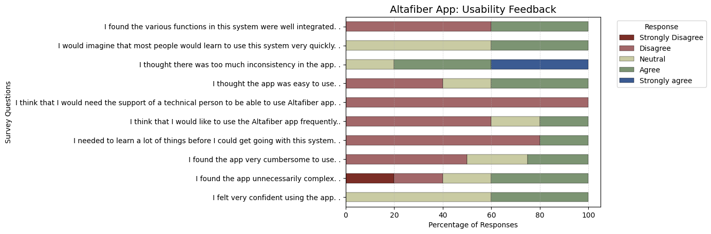Summary of findings: The chart shows mixed feedback on the Altafiber app: users felt generally confident and found it learnable, but many noted issues with complexity, inconsistency, and cumbersomeness, suggesting an uneven user experience.

Chimaroke U – Capturing UI/UX Methods:

Do at least some of this work (e.g., interview a few people, create and share the survey, run one study with a user) and describe your initial findings.

We conducted four short think-aloud sessions with users to observe how they navigate the Altafiber mobile app and what thoughts or emotions they express while navigating.

**Self-Reported Metrics**

- Peter (User 1) found the Messages section confusing, since you have to open “Messages” and then “Inbox.” He also said he never uses the Fioptics TV feature under “More.”

- Joseph (User 2) said the blog on the home page isn’t needed and that it makes the page look messy.

- Frank (User 3), a new user, couldn’t find his profile right off looking at the interface as he had to go through the nav to finally see it hidden under “More,” which wasn’t intuitive.

Joanne (User 4), mostly uses the app from memory, doesn’t use the TV cable option, and said the home page should have quick links for common tasks on the homepage.

**Performance Metrics**

During the think-aloud, users were asked to check their bill, enroll in autopay, find help for a billing issue, and contact support.

Everyone said they sometimes had to guess or rely on memory to reach certain pages.

- Frank (User 3) spent time searching for his profile, clicking through several options before finding it.

- Setting up autopay wasn’t difficult for users, and most were able to complete it without help.

- Users said the same thing about reaching the Inbox page, which required extra steps going through multiple layers.

- Users mentioned that contacting support wasn’t very efficient, as they had to go through several nested menus to find it. They said there should be a direct button in the Help section to access support faster.

- User 3 clicked on the Total Bill amount, thinking it was a link that would open more details, mainly because of the way it was styled

**Design Plans Based on Findings**

Our initial findings are the following:

Users are annoyed with the messaging system, and they say it is not convenient to use, whether that be finding a message from the past or sending a message to their agent.

Users think the home screen is confusing, and the more options page is hard to navigate.

Some users do not know how to set up their account at all.

Based on these findings, we believe the UI can be more informative, and can also be organized better to help users navigate and complete their tasks (paying a bill, setting an account, etc.)

SKETCHING:

Get together with your group to do some preliminary sketching activities.  Select a sketching method.  Work together on a set of sketches.  Submit drafts of these sketches here.

Our sketching method is 10x10 sketches. Below are the results for each person:

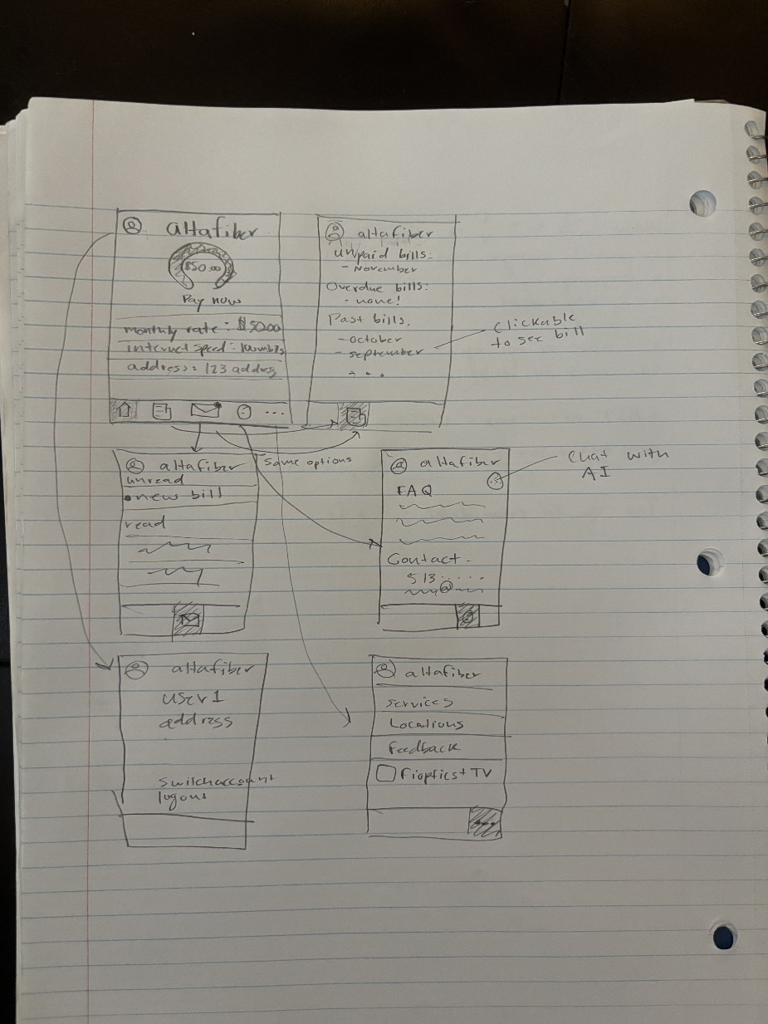

* Eli

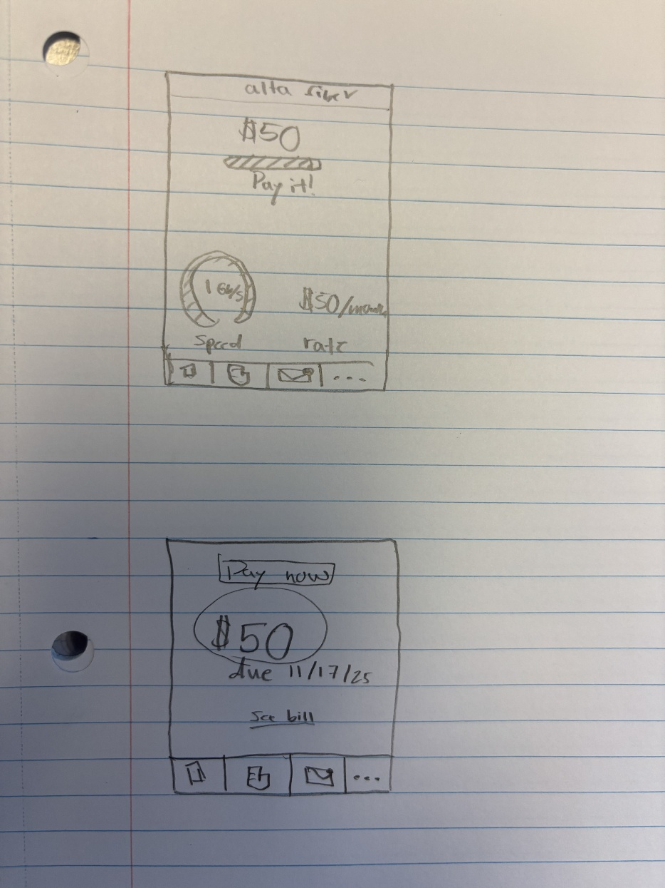

* Eli

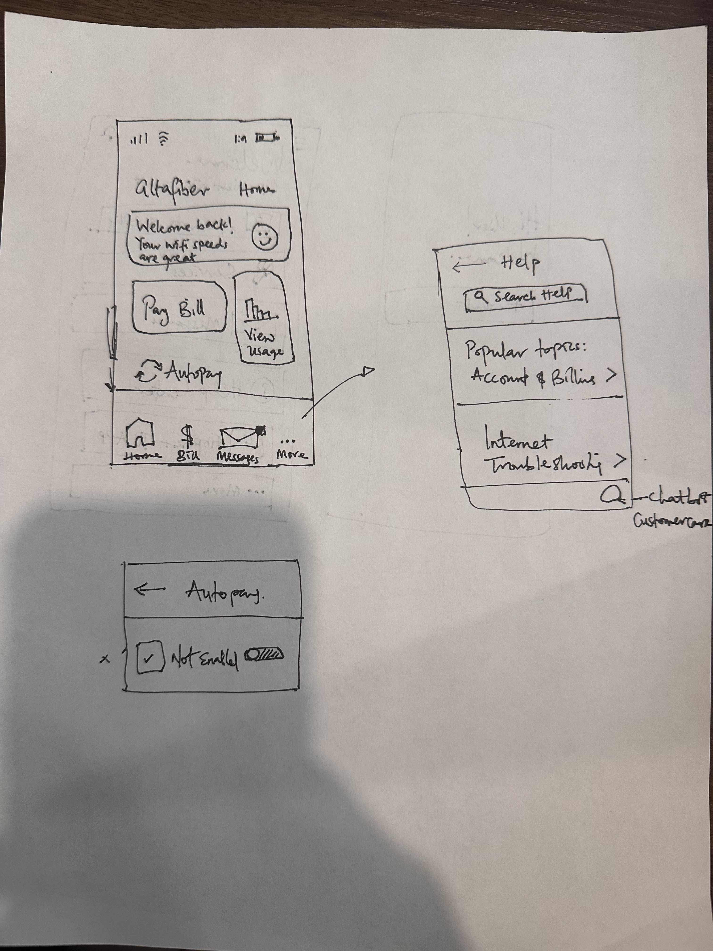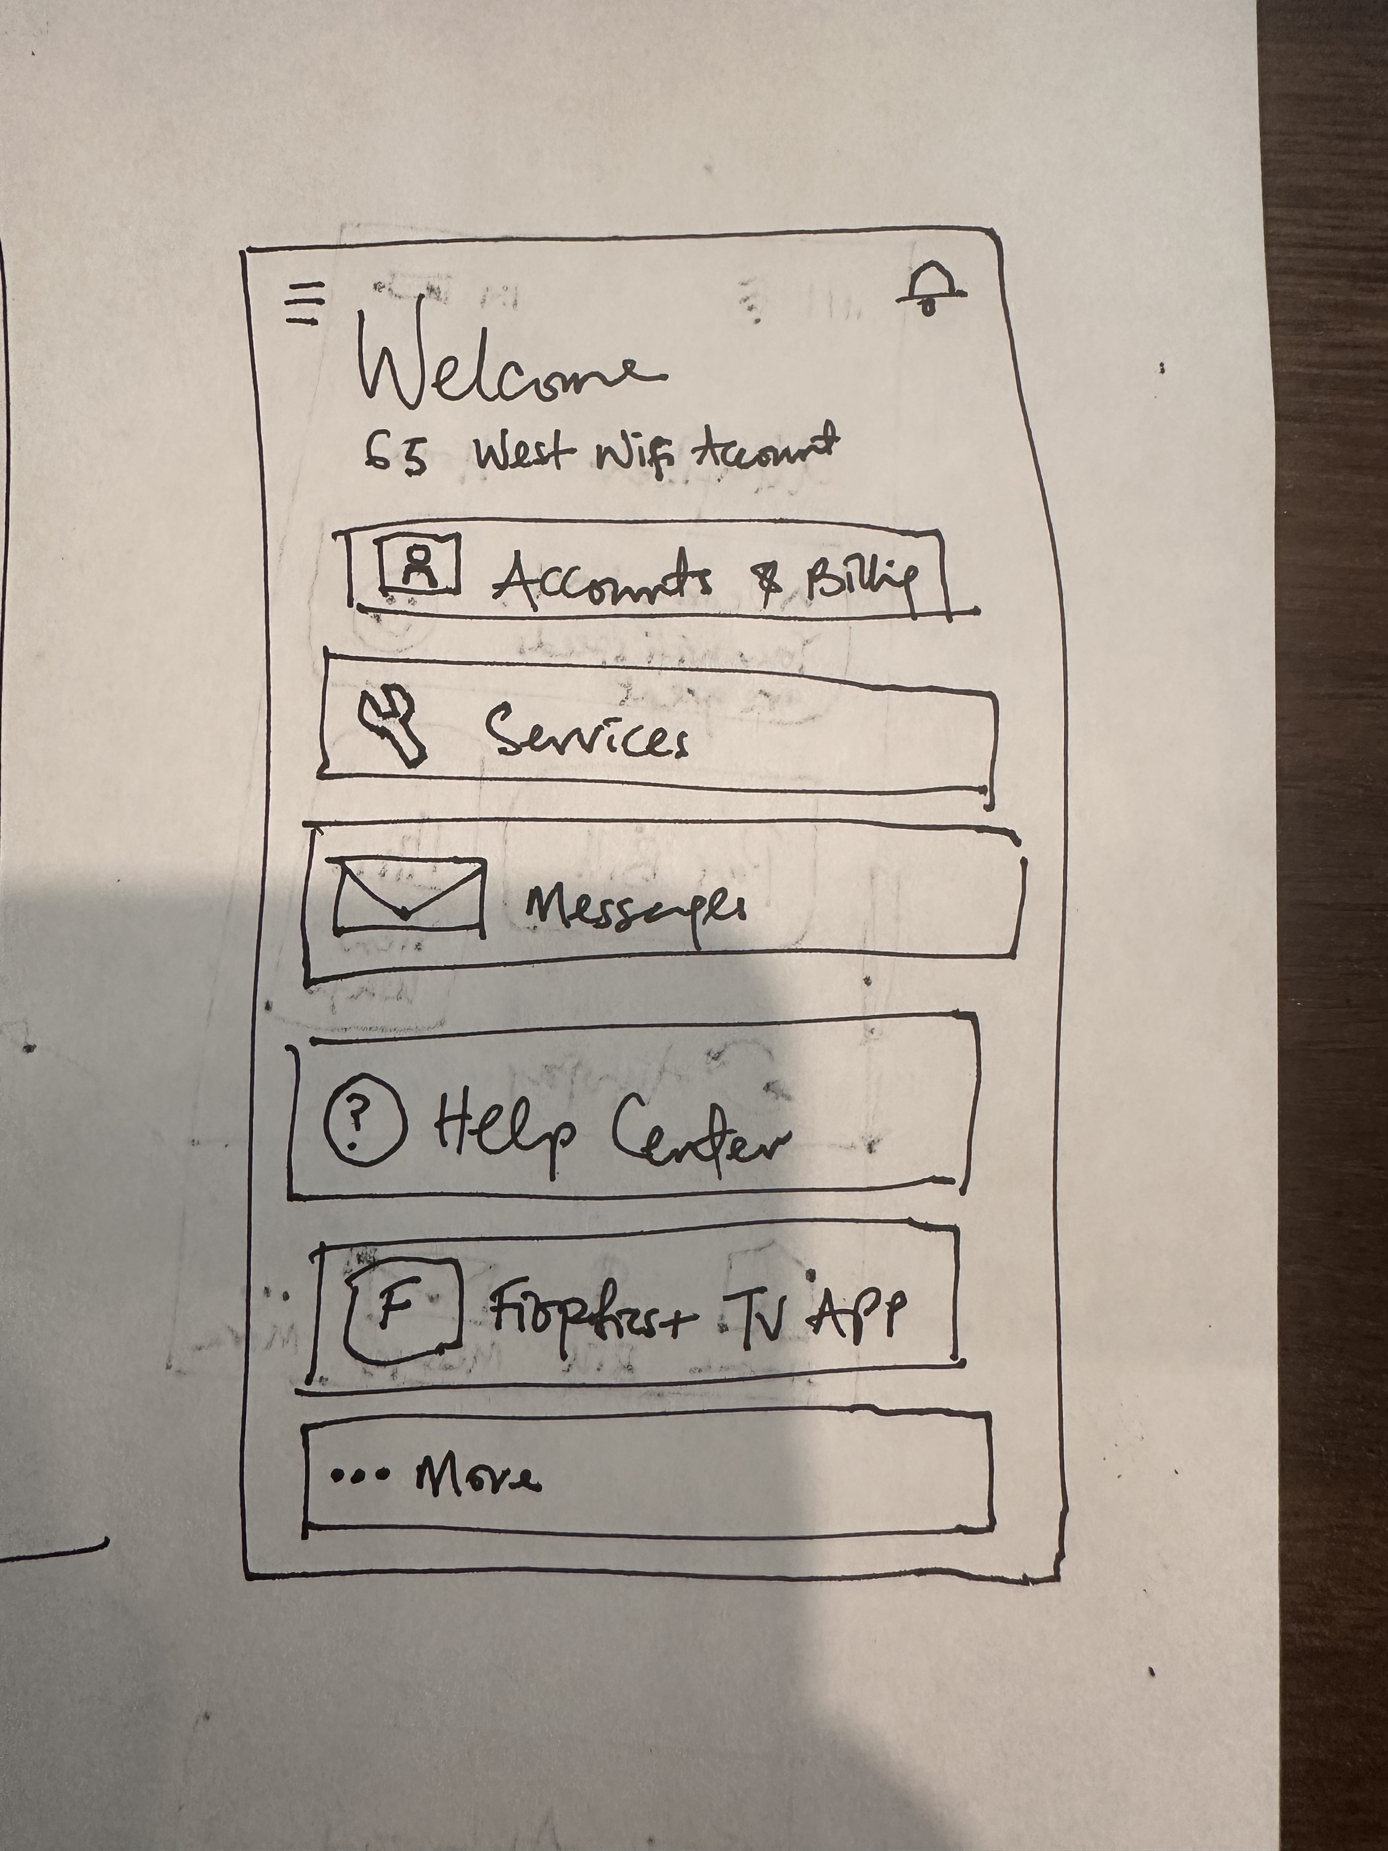

-Joanne

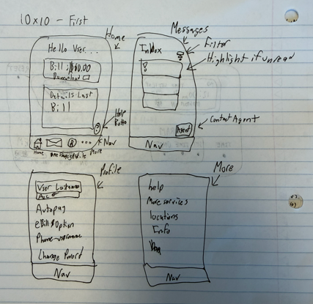  
- Joe

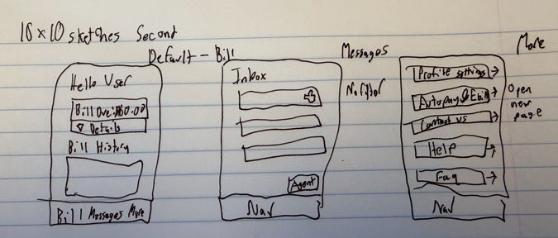  
- Joe

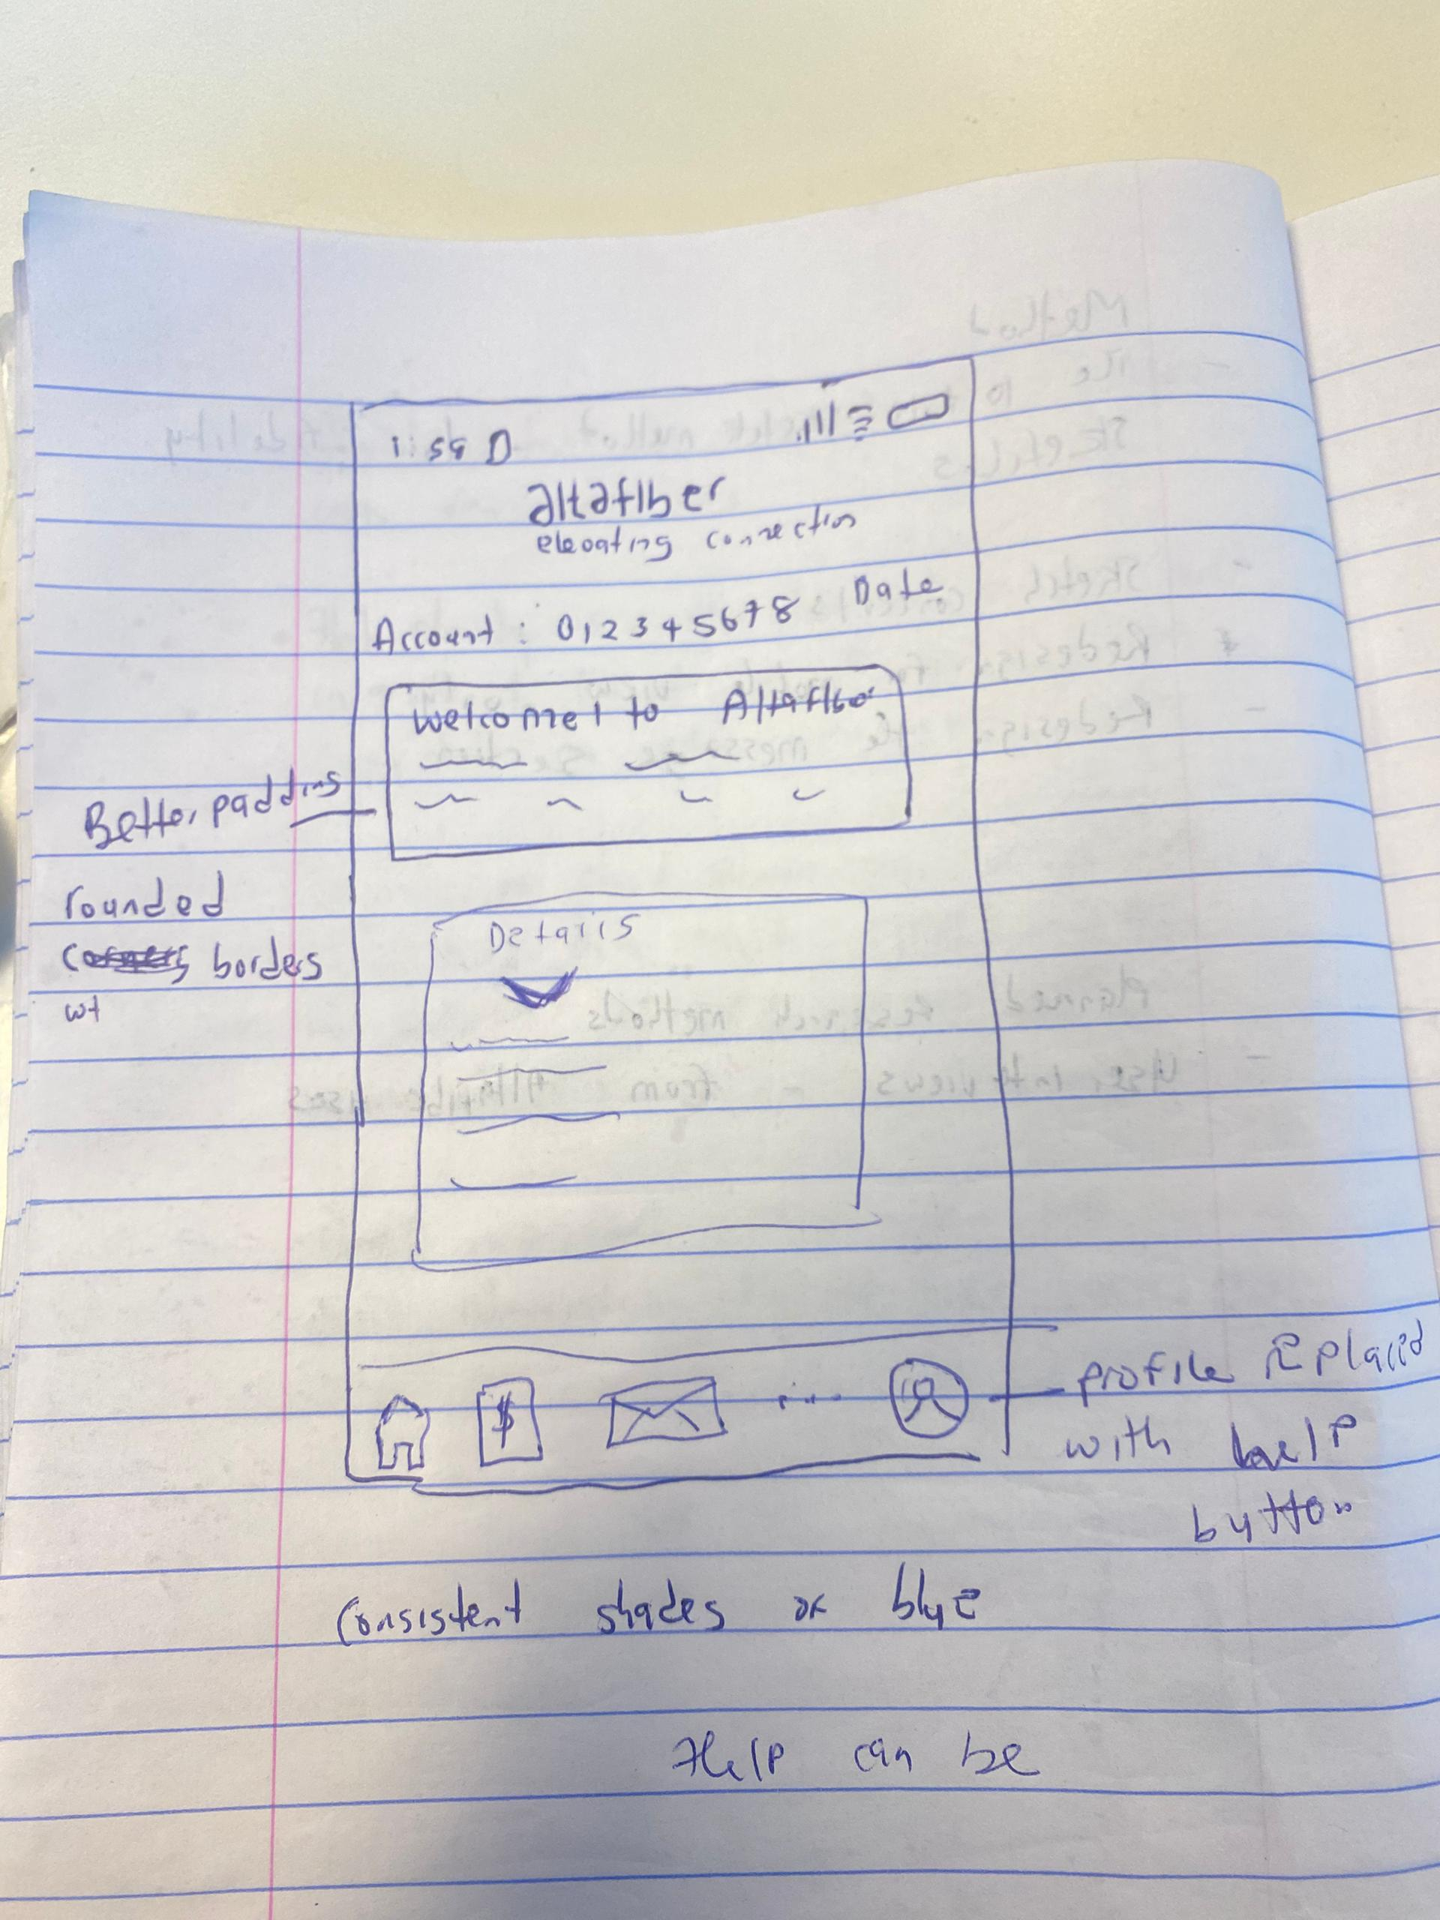

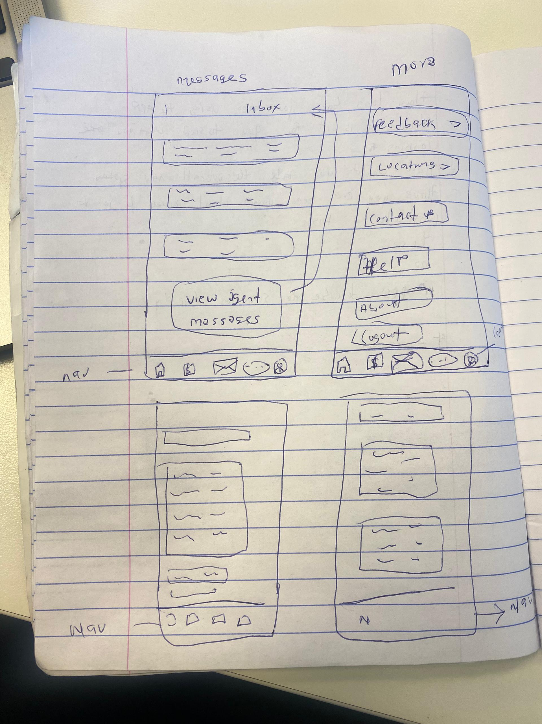

- Chimaroke Joseph